
BRIDG Model
http://www.bridgmodel.org
How to Build a BRIDG-Based Analysis Model
Prepared by BRIDG Semantic Coordination Committee (SCC)

Becky Angeles (ScenPro/NCI/HL7 RCRIM)
Julie Evans (CDISC/HL7 RCRIM)
Smita Hastak (ScenPro/NCI/HL7 RCRIM)
Lloyd McKenzie (Gordon Point Informatics/NCI/HL7)
Charlie Mead (NCI/HL7)
Steve Sandberg (ScenPro/NCI/HL7 RCRIM)
Wendy Ver Hoef (ScenPro/NCI/HL7 RCRIM)
6 September 2011


How to Build a BRIDG-Based Analysis Model

Table of Contents
Revision History 2
Scope of this Document 2
Steps for Building a BRIDG-Based Model 2

Revision History
Version Number | Date | Summary of Changes
1.0 | July 9, 2010 | First version of document
1.1 | June 13, 2011 | Updated text and graphics
1.2 | Sept. 6, 2011 | Incorporated SCC comments

Scope of this Document
This document describes the process for creating a BRIDG-based analysis model using a copy of the BRIDG model Enterprise Architect file, adding a project-specific diagram and package, extending the model to include new semantics, and constraining existing classes to reflect project needs.
This document is to be used by project teams that wish to harmonize with BRIDG but do not have an analysis model. Their semantics may be in spreadsheet format, a set of metadata (CDEs), a logical or physical model or other formats. Teams should build a BRIDG-based model as they are mapping their semantics to BRIDG using the BRIDG Mapping Spreadsheet Template.xls. This model can be built in concert with the mapping or when the mapping is complete. Project teams that do not have a BRIDG-based analysis model, regardless of what other models they may have, may want to create a BRIDG-based model to facilitate re-harmonization of later versions with BRIDG. This also provides a view of their subset of the BRIDG semantics.
Note that this document outlines steps that are needed to build a BRIDG-based model, but not necessarily all the steps have to be performed in a particular sequence. Adapt the steps as best fits your process and iterate as needed.

Steps for Building a BRIDG-Based Model
- Download the latest released BRIDG model from: http://gforge.nci.nih.gov/frs/?group_id=342
- Read the release notes and other BRIDG documentation that is included in the release package as necessary.
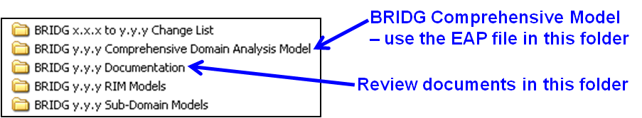
- Review the BRIDG Comprehensive Domain Analysis Model.EAP file, especially the “UML-Based Comprehensive BRIDG Model Diagram” and the sub-domain packages which group the BRIDG classes into logical sets of related concepts. Each sub-domain package contains a diagram showing all the classes in that package, plus any relevant classes from other sub-domain packages. Review other diagrams if applicable.
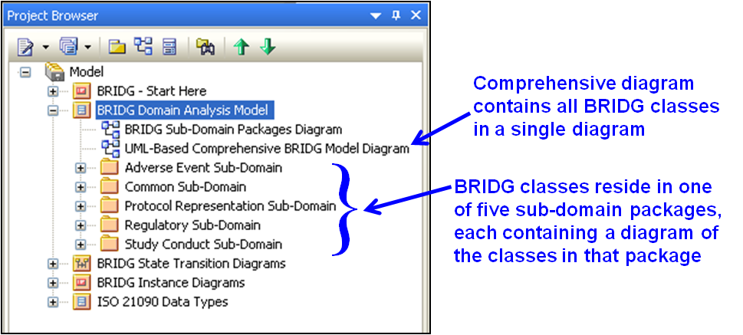
- Copy the BRIDG Comprehensive Domain Analysis Model.EAP file as the starting point for your analysis model, then save the file as “Your Project” BRIDG-Based Analysis Model.EAP.
- Add a package with a class diagram in the Project Browser to represent your domain analysis model.
  - Right click on the BRIDG Domain Analysis Model Package and select Add > Add Package. Type in ’“Your Project” Analysis Model’ in the New Model Package pop-up window, check the “Automatically add new diagram” box and click OK. Next, in the New Diagram pop-up window, select “Class” as the Diagram Type and click OK. This will add a new package and an empty class diagram to the Project Browser.
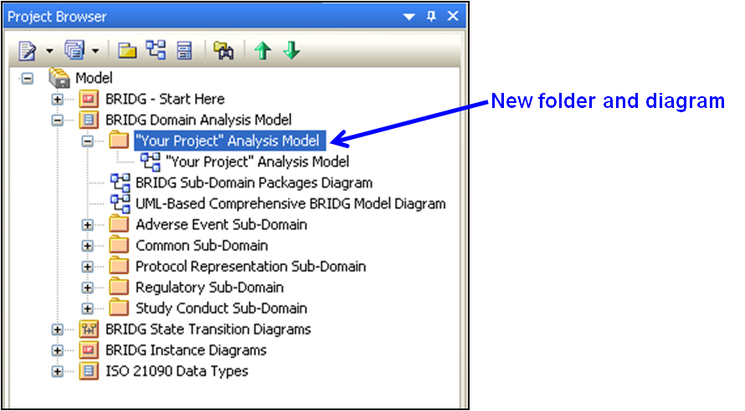

- Identify which BRIDG classes (from the sub-domain packages) pertain to your analysis model and drag those classes from the Project Browser onto the new diagram view you just added in Step 5. If you have already created a mapping spreadsheet identifying how project semantics map to the BRIDG model, use the distinct list of BRIDG classes identified in that spreadsheet as your starting point. When dragging classes into the diagram, make sure to select the “as Simple Link” option in the Paste Element window.
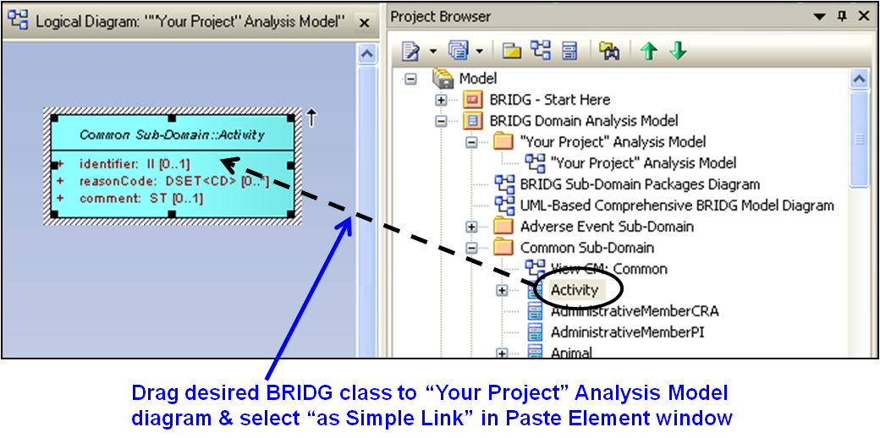
- When adding existing classes to a diagram, EA will bring in any existing associations between the class being added to the diagram and any other classes already on the diagram. For any associations that are not needed, add a stereotype such as “Not Used” and color the association red to indicate that it is not used. BRIDG SCC recommends keeping it on the diagram as a reminder of what associations exist so that redundant associations are not accidentally added. Keeping “Not Used” associations in the diagram can also be helpful in subsequent rounds of harmonization when new project semantics are added.
- Add any new attributes** to the existing BRIDG classes that are needed for your domain
  - Ensure all new attributes are fully defined with examples; specifying other names and notes is optional
  - Select a data type for the attribute using the ISO 21090 data types
- If you have the need to modify the definition, name or data type of an existing BRIDG class or attribute** – add a new subclass with a generalization association to the desired BRIDG class. Name the new subclass with a modified version of the BRIDG class name (i.e., “Person-MODIFIED”). Add any attributes to the subclass that you wish to modify from BRIDG (i.e., name).
  - Ensure any modifications have a precise definition, example and data type (if applicable)
- Add new classes** that your analysis model needs to the package you created in Step 5
  - Ensure new classes are fully defined with examples
- Add new attributes** to your new classes
  - Ensure new attributes are fully defined with examples
  - Select a data type for the attribute
- Add desired associations** between new and/or existing classes
  - Ensure associations have cardinality on both ends
  - It is helpful to include a label on the association to characterize the relationship between the classes
NOTE: If an association is added between two existing BRIDG classes, this would be considered a change to the semantics within the BRIDG model. It is recommended to add a note on the diagram near the association indicating which association was added. Also consider using a different color for the new association to help highlight the addition (BRIDG SCC recommends bright green).
- Modify cardinality** on existing associations as needed
  - Your model may have a need to constrain the cardinality on an existing association - that is expected since the BRIDG model covers a wide range of semantics.
  - Your model may also bring a new use case for which the cardinality needs to be less constrained or loosened. This is considered new semantics in the BRIDG Model that could affect the interoperability of other implementations.
NOTE: It is recommended that you add a note on the diagram near the association indicating any cardinality change.
- Modify a data type** on an existing attribute as needed
  - BRIDG uses ISO 21090 data types that can be specialized to more narrowly constrain the data type for a specific purpose. For instance, a timestamp (TS) can be constrained to a simple date (TS.DATE), an integer (INT) can be constrained to a positive number (INT.POS), and an entity name (EN) can be constrained to a person name (EN.PN). Such changes can be made to the model for a specific project without changing the interoperability of the model. However, changing a data type without using specialization, from string (ST) to code (CD) for instance, would change the interoperability of the model.
NOTE: It is recommended that you add a note on the class diagram near the class, indicating which attribute(s) had a data type change and what the change was.
- Mark any attributes you use or don’t use with a stereotype such as “UsedByProjectX” or “NotUsed”. This will make a visual distinction in the diagram that can be very helpful when reviewing the model within the team or with the BRIDG SCC and also allows for later use of existing attributes not originally needed.
** Consult the BRIDG Modeling and Naming Conventions document (available in the BRIDG Harmonization Package, downloadable from www.bridgmodel.org) for guidelines on creating classes, attributes and associations. For technical instructions on how to add classes, attributes and associations or modify data types or cardinality in your model, please consult the Enterprise Architect Help file.

